KEYAZ CONSULTANCY
MIDTERM II EXAMINATION 2023
Age Group (3 – 4 years): BABY CLASS
Learning Area 5: Reading

My name is __________________________________________
- Read and act these sounds.
a b c e f i
j m n p r s
t v
Shade for sound ‘s’
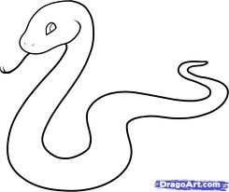

- Match and write.
f v _____________

m c ____________

v o ____________

c f _____________

o m ___________
- Match pictures to sounds.
 t

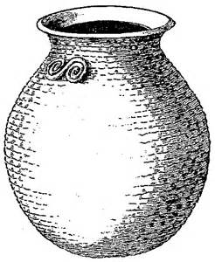 a
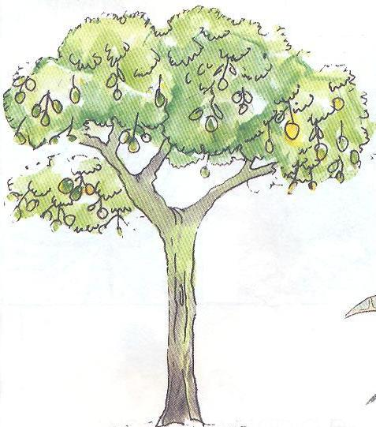 s
 p
- Circle the odd man out.
n m n

i i h

s r r

f b f

- Copy these sounds.
f | c | t | a | i
End

